**Diablo III BuildMark**



Release #1

v1.3

October 20, 2015

**Alex Carlson**

[alexander.carlson@oit.edu](mailto:alexander.carlson@oit.edu)

**Signature Page**

This document accepted by:

_______________________________ ___________________

Signature (Calvin Caldwell) Date

This document submitted by:

_______________________________ ___________________

Signature (Alex Carlson) Date

**Revision History**

|  |  |  |  |  |  |
| --- | --- | --- | --- | --- | --- |
| **Author** | **Company** | **Date** | **Version** | **File Name** | **Comments** |
| Alex Carlson | AC software | 10/18/2015 | v1.0 | Diablo III BuildMark – Use Case Model 1.0.docx | Created initial document with title page. |
| Alex Carlson | AC software | 10/19/2015 | v1.1 | Diablo III BuildMark – Use Case Model 1.1.docx | Wrote feature verification matrix. |
| Alex Carlson | AC software | 10/20/2015 | v1.2 | Diablo III BuildMark – Use Case Model 1.2.docx | Wrote Use Case Catalog, edited Feature Verification Matrix and Context Diagram. |
| Alex Carlson | AC software | 10/20/2015 | v1.3 | Diablo III BuildMark – Use Case Model 1.3.docx | Designed Low Fidelity UI, Wrote CRUD Matrix, Business Rules, edited Use Case Catalog, and Feature Verification Matrix. |

**Table of Contents**

Signature Page 2

Revision History 3

Signature Page 4

Context Diagram 5

Use Case Catalog 6

Actor Catalog 7

Features Verification Matrix 8

Use Case Specifications 9-x

CRUD Matrix x

Low Fidelity UI x

Glossary x

Appendix A – Business Rules x

**Context Diagram**



**Use Case Catalog**

|  |  |  |
| --- | --- | --- |
| **Use Case ID** | **Use Case Name** | **Description** |
| P-000 | User Registration | User wants to register an account |
| P-005 | User Login | User wants to login with their account |
| P-010 | Create Profile | User wants to create profile for their account |
| P-015 | Edit Profile | User wants to edit profile for their account |
| P-020 | Add Hero | User wants to add a hero build |
| P-025 | Save Hero Snapshot | User wants to save a hero build snapshot |
| P-030 | Update Hero | User wants to update a hero to the latest version |
| P-035 | Edit Account Settings | User wants to edit account settings |
| UX-000 | View Profile | User wants to view a user’s profile |
| UX-005 | View Hero | User wants to view a profile’s hero build |
| UX-010 | Compare Hero Snapshots | User wants to compare two hero builds at once |
| UX-015 | View Hero Benchmarks | User wants to view benchmarks for a hero build |
| UX-020 | Search | User wants to search for users and/or hero builds |
| S-000 | Update Benchmarks | System calculates benchmarks for builds |
| S-005 | Retrieve Profile | System retrieves profile info from Blizzard |
| S-010 | Retrieve Hero | System retrieves hero build info from Blizzard |

**Actor Catalog**

|  |  |  |
| --- | --- | --- |
| **Name** | **Type** | **Description** |
| Registered User | Person | A user that has previously been registered and is currently logged in. |
| Anonymous User | Person | A user that has not yet logged in. |
| Blizzard API | System | The official blizzard API for retrieving Diablo III player data. |

**Feature Verification Matrix**

|  |  |  |
| --- | --- | --- |
| **Feature #** | **Use Case ID** | **Use Case Name** |
| 1A | P-000 | User Registration |
| 1B | P-005 | User Login |
| 2A | UX-000 | View Profile |
| 2B | P-010 | Create Profile |
| 2B | P-015 | Edit Profile |
| 2C | P-020 | Add Hero |
| 2C | P-030 | Update Hero |
| 3A | UX-005 | View Hero |
| 4A | S-005 | Retrieve Profile |
| 4B | P-025 | Save Hero Snapshot |
| 4B | S-010 | Retrieve Hero |
| 4C | P-035 | Edit Account Settings |
| 5A | UX-010 | Compare Hero Snapshots |
| 6A | UX-005 | View Hero |
| 6A | S-000 | Update Benchmarks |
| 6B | UX-005 | View Hero |
| 7A | UX-015 | View Hero Benchmarks |
| 7A | S-000 | Update Benchmarks |
| 7B | S-000 | Update Benchmarks |
| 7C | S-000 | Update Benchmarks |
| 8A | UX-020 | Search |
| 8B | UX-020 | Search |

**Crud Matrix**

|  |  |  |  |  |  |
| --- | --- | --- | --- | --- | --- |
| **UC ID** | **UC Name** | **C1** | **C2** | **C3** | **C4** |
| P-000 | User Registration |  |  |  |  |
| P-005 | User Login |  |  |  |  |
| P-010 | Create Profile |  |  |  |  |
| P-015 | Edit Profile |  |  |  |  |
| P-020 | Add Hero |  |  |  |  |
| P-025 | Save Hero Snapshot |  |  |  |  |
| P-030 | Update Hero |  |  |  |  |
| P-035 | Edit Account Settings |  |  |  |  |
| UX-000 | View Profile |  |  |  |  |
| UX-005 | View Hero |  |  |  |  |
| UX-010 | Compare Hero Snapshots |  |  |  |  |
| UX-015 | View Hero Benchmarks |  |  |  |  |
| UX-020 | Search |  |  |  |  |
| S-000 | Update Benchmarks |  |  |  |  |
| S-005 | Retrieve Profile |  |  |  |  |
| S-010 | Retrieve Hero |  |  |  |  |

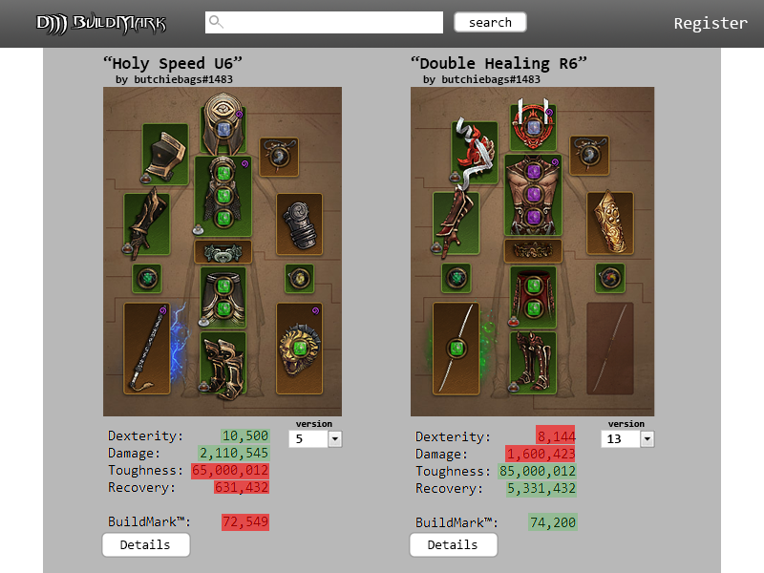**Low Fidelity UI (Compare Hero Snapshots)**

**Glossary**

**Appendix A**

**Business Rules**

**1. The system shall supply the user with a web-interface supporting user logins.**

A. The website shall provide a registration page.

i. It shall require a unique username at least six characters long.

ii. It shall require the user enters a new password twice.

a. Both passwords must be at least six characters long.

b. Both passwords must match.

iii. It shall check the database for pre-existing account information.

iv. It shall store valid, unique user login information in the database.

a. The username.

b. The hashed password.

iii. It shall direct the user to the login page upon successful registration.

iv. It shall display warning text when a user attempts to enter invalid information.

B. The website shall provide a login page.

i. It shall require a username.

ii. It shall require a password.

iii. It shall hash the password and check against existing password in the database.

C. The website shall provide an account settings page for editing account information.

i. The user’s password.

ii. The user’s battle.net profile.

**2. The system shall support viewing and storing of a user’s battle.net profile.**

A. The website shall provide a profile viewing page.

i. It shall allow the user to connect the profile with its battle.net battletag.

ii. It shall display one profile per registered user.

iii. It shall display the profile’s battletag.

iv. It shall display a list of all heroes belonging to the battletag.

a. Each hero listed shall display the hero’s name.

b. Each hero listed shall act as a link to the hero build viewing page (4.D).

B. The database shall store the user’s battle.net battletag (for use with Blizzard API).

C. The database shall store a list of the user’s heroes.

**3. The system shall allow viewing of all user’s hero builds and their saved states.**

A. The website shall provide a hero build snapshots viewing page.

i. It shall display the hero’s name.

ii. It shall display the hero’s attribute values.

a. Strength, Dexterity, Intelligence, Vitality, Damage, Toughness, Recovery, and Life.

iii. It shall display the hero’s build.

a. A list of all four of the hero’s passive skills.

b. A list of all six of the hero’s active skills.

**4. The system shall allow saving a hero’s build state at any time chosen by the user.**

A. Saving a hero’s build uses the Blizzard API to acquire the hero’s current build.

B. Saving a hero’s build adds it to a list of build states stored in the database.

**5. The system shall allow comparing saved build states.**

A. The website shall provide a page for comparing build states.

i. It shall provide two drop-down lists of saved build states for the current hero.

ii. It shall provide two of the current hero’s build states side-by-side.

iii. It shall allow changing of either build state to a different build state.

iv. It shall highlight attributes that are greater than those of the other build.

**6. The system shall provide benchmark numbers for a given build.**

A. The website shall display benchmark information on the build viewing page.

i. It shall provide a button for calculation of a benchmark for each build state.

ii. It shall provide two arbitrary benchmark numbers indicating build effectiveness.

a. A number indicating the build’s single-target effectiveness.

b. A number indicating the build’s multiple-target effectiveness.

B. The benchmark information will be retrieved from the database.

**7. The system shall provide a benchmarking tool for calculating build effectiveness**

A. The server will process benchmarks in a queue, being added by the users.

B. The server will run a series of simulations on each build in the queue.

i. A simulation testing the build’s defense against a series of opponents.

ii. A simulation testing the build’s offense against a series of opponents.

iii. A simulation testing both defense and offense together against a series of opponents.

C. The database will be updated with benchmark results on completion of each benchmark.

**8. The system shall provide searching for users and hero builds**

A. The website shall provide a search field in the navigation bar.

B. The website shall provide a page for search results.

i. The page shall provide a list of links to found profile and hero pages.